For Immediate Release August 25, 2018
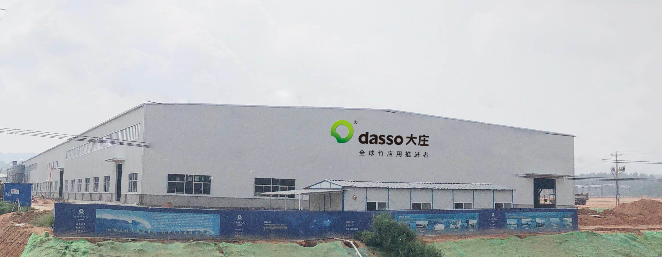
Grand Opening of
dasso Group’s 8th Factory
ATLANTA—dasso commissioned its 8th factory today, Jiangxi Zhushang Bamboo Industrial Co., Ltd, at Zixi County, Jiangxi. The new state of the art facility, built to replace an older plant, will produce 10 million sqft (1 million m2) of dassoXTR Classic and Epic Fused Bamboo® annually–a 400% increase over previous production levels. Erected on 20 acres of land, the factory has sufficient space for future expansion.
dasso Group thanks all of its customers, suppliers, and employees for their continued support and dedication in making this relocation a success. The rebuilding of the Jiangxi Zhushang factory was completed one day shy of 14 months. The project progressed from an empty field to producing its first dassoXTR Fused Bamboo® board in a short period of time.
dasso will begin dassoXTR Epic Fused Bamboo® production at the new Jiangxi Zhushang Bamboo Industrial Co., Ltd. location.

